**Master of Science in Information Systems, ongoing**

10 plus merit certificates



Birthday

**22.06.1994**

Experience

**3 Years +**

**Hikmatullah SAQIB**



[manager.program@apbho.org](mailto:manager.program@apbho.org) & [hsaqibsz@gmail.com](mailto:hsaqibsz@gmail.com)

2016 – 07.19

31.12.2016

2019 – to Date

**Coordination/Reporting**

**Data Management & Analysis/visualization**

**Assessment/Research**

**References:**

Will be provided upon demand

**MCS Specialization in Information Systems, Ongoing  
Bakhtar University of Kabul, Afghanistan**

Af

Kabul

01.04.2019

**Software Engineer, Syberaan Afghanistan**

I was responsible to develops information systems by designing, developing, and installing software solutions.

Determining of operational feasibility by evaluating analysis, problem definition, requirements, solution development, and proposed solutions.

Kabul

kabul

Khost

kabul

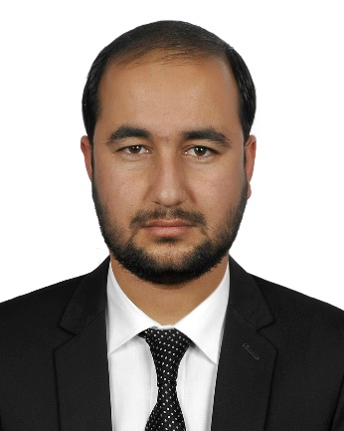

Swimming

Photography

GYM

Cricket

**HOBBIES**

2017

**7 Online Tope Courses Certified**

**Udemy, EDX.**

**Saba University**

Internet

2014

**Advanced Software Engineering plus HRM project design**

**Synaps Technologies of Kabul, Afghanistan**

**Saba University**

Kabul

2001-2012

**High School, Completed  
Mahmood-e-hotaki high school of Kabul, Afghanistan**

Kabul

**Creativity**

**PERSONAL SKILLS**

Kabul Afghanistan

Kabul

**I’m a professional soft skills & program support expert with the ability of multi-task and work under pressure. I can work independently and also as an effective team member, I’m willing to enhance knowledge through training and personal initiative, committed to human rights, equality, the role & empowerment of women, minorities and persons with disabilities. I’m flexible, adaptable & sense of humor.**

**Team Work**

**Time Management**

**Leadership**

**BCS Specialization in Information Systems, Completed  
Shaikh Zayed University of Khost, Afghanistan**

Af

**Program Manager, Afghan Peace Builders Humanitarian Organization**

* Organizing programs and activities in accordance with the mission and goals of the organization.
* Developing new programs to support the strategic direction of the organization.
* Creating and managing long-term goals.
* Developing a budget and operating plan for the program.
* Developing an evaluation method to assess program strengths and identify areas for improvement.

**MIS/Program officer, Organization for Relief Development**

* I was responsible for planning, development and implementation/maintenance of hardware, software applications, programming and systems network and integration of a management information system.
* Supporting M&E colleagues in conducting need assessments/data analysis, visualization and reporting. Processing of program relevant document, developing comprehensive reports on humanitarian and development projects.

2010-2011

2013-2016

Dari

English

Pashto

**DEL**Azeraksh Institute on computer and English Language.

* Six-month intermediate level English language program at the embassy of United States.

**PROFESSIONAL EXPERIENCE**

**EDUCATION**

**Achievement 1**  
Achieved certificate of student of the year from university students union.

**Achievement 2**achieved certificate of excellent problem solver in field level from ORD.

**LANGUAGES**

**PROFESSIONAL SKILLS**

**ACHIEVEMENTS**

**Website & Database 1**

**Program Support/Management**

[***www.ord.org.af***](http://www.ord.org.af)

+93787772013, +93782003048